Steps to make speedfan close and run again when using switch user in Windows 7 (and probably Vista – haven’t tested on vista myself).
Step 1
Create a batch file (kill_speedfan.bat) and save it in c:\windows containing the following:
@echo off
taskkill /f /im speedfan.exe
This is the command used to close speedfan.
Note: It would have been good to have an /exit command or similar in speedfan so that it closes more “properly” than killing the process. Also, when closed this way, speedfan setting “set fans to 100% on exit” obviously doesn’t work. Any suggestions are welcome.

Step 2 – speedfan settings
The only setting that is necessary is the “start minimized” in options.

Step 3 – create the tasks in task scheduler
- Task to start speedfan
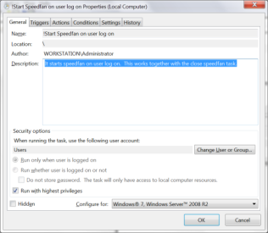
Note that you should run it with “Users” group and configure for “Windows 7 etc”
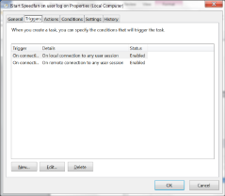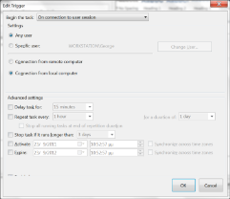
Triggers is very important – the second one is not really necessary but you should select the “on connection to user session” and not the “At log on” because if you use the last one, speedfan will start with the number of users you have in your machine, ie if you have 4 users you will have 4 speedfans running!

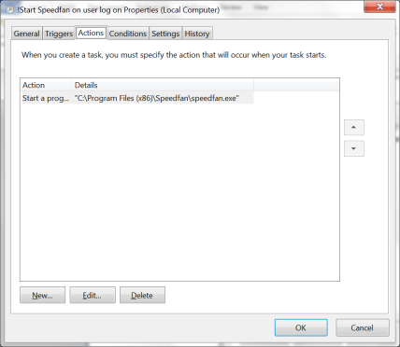
Here is what you do, ie you tell it to run speedfan.

The remaining settings don’t really make a difference – you can leave them in default – but make sure the “allow task to run on demand” is checked.
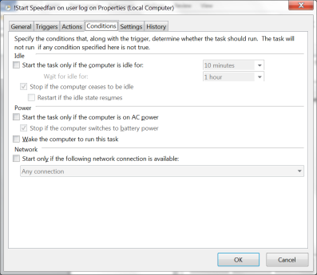
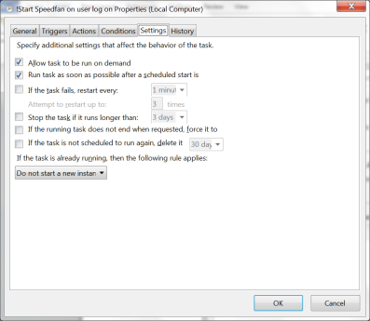

- Task to stop speedfan at log off or user switch.

As before, you run it with the users group and Windows 7 settings
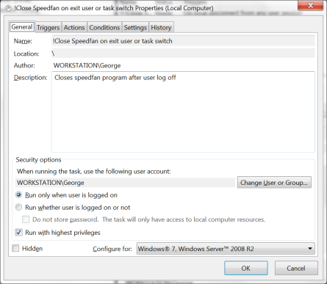

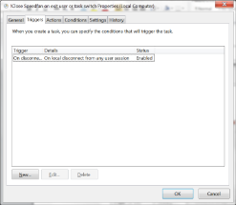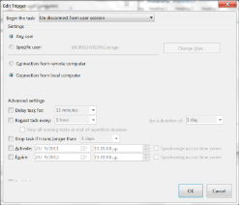
As it says above

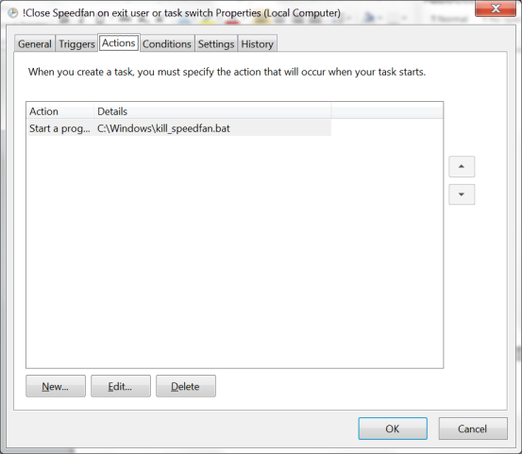
The action is that you run the batch file you created earlier.

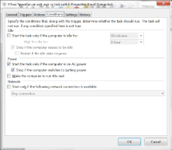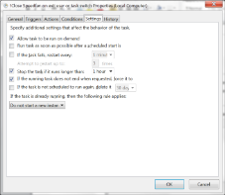
Leave the remaining settings to default and make sure the run on demand is checked. One last thing….

A final but very important note: In my system for some reason, this works perfectly when a user that is logged on previously and then you use the switch user function and log on with the same user. Speedfan closes and opens again. But strangely, when you do the initial log on, speedfan doesn’t start with the scheduled task. That’s why you should keep speedfan in the all users start up folder. Probably you have it there already but it won’t mind to check again
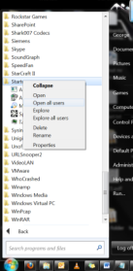 Then a window opens and make sure you have a shortcut of speedfan in there…
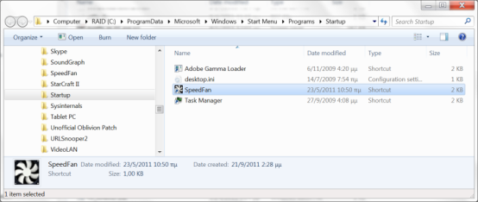

That’s it!

